INTRODUCTION
Whether you want to advertise a service, event, or product, or merely want to inform the public about a current topic of interest, brochures are a popular type of promotional publication. A brochure, or pamphlet, usually is a high-quality document with lots of color and graphics, created for advertising purposes. Businesses that may not be able to reach potential clientele effectively through traditional advertising such as newspapers and radio can create a long-lasting advertisement with a well-designed brochure.
Brochures come in all shapes and sizes. Colleges and universities produce brochures about their programs. The travel industry uses brochures to entice tourists. Service industries and manufacturers display their products using this visual, hands-on medium.
Project 3 uses Microsoft Publisher to illustrate the production of the two-page, tri-fold brochure. The brochure informs the public about engineering scholarships at the local college. Each side of the brochure has three panels. Page 1 contains the front and back panels, as well as the inside fold. Page 2 contains a three-panel display that, when opened completely, provides the reader with more details about the scholarships and a sign-up form.
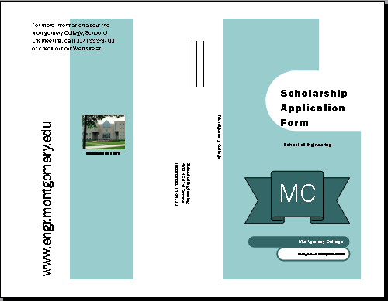
On page 1, the front panel contains shapes, text boxes, and a graphic, designed to draw the reader’s attention and inform the reader of the intent of the brochure. The back panel, which displays in the middle of page 1, contains the name of the school, the address, and a place for the sender to enter a return address. The inside fold, on the left, contains the contact information and Web site for the college, with a colored background and graphic.
The three inside panels on page 2 contain more information about scholarships, graphics, and a form the reader may use to apply.
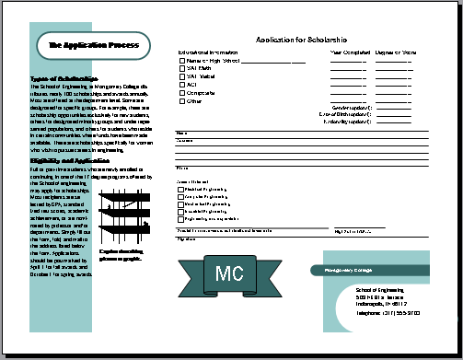

THE BROCHURE MEDIUM
Brochures are professionally printed on special paper to provide long-lasting documents and to enhance the graphics. The brochure medium is intentionally tactile. Brochures are meant to be touched, carried home, passed along, and looked at, again and again. Newspapers and fliers usually are produced for short-term readership on paper that soon will be thrown away or recycled. Brochures frequently use a heavier stock of paper so they can stand better in a display rack.
The content of a brochure needs to last longer too. On occasion, the intent of a brochure is to educate, such as a brochure on health issues in a doctor’s office; but more commonly, the intent is to market a product or sell a service. Prices and dated materials that are subject to frequent change affect the usable life of a brochure.
Typically, brochures use a great deal of color, and they include actual photographs instead of drawings or graphic images. Photographs give a sense of realism to a publication, and should be used to show people, places, or things that are real, whereas images or drawings more appropriately are used to convey concepts or ideas.
Many brochures incorporate newspaper features such as columns and a masthead, and the added eye appeal of logos, sidebars, shapes, and graphics. Small brochures are separated into panels and folded. Larger brochures resemble small magazines, with multiple pages and a stapled binding.
Brochures, designed to be in circulation for longer periods as a type of advertising, ordinarily are published in greater quantities and on more expensive paper than newsletters and are, therefore, more costly. The cost, however, is less prohibitive when produced in-house using desktop publishing rather than hiring an outside service. The cost per copy is sometimes less than a newsletter, because brochures are produced in mass quantities.
Table 3-1 lists some benefits and advantages of using the brochure medium.
Table 3-1 Benefits and Advantages of Using the Brochure Medium
AREA | BENEFITS AND ADVANTAGES
Exposure | An attention getter in displays  A take-along document encouraging second looks  A long-lasting publication due to paper and content  An easily distributed publication — mass mailings, advertising sites
Information | Give readers an in-depth look at a product or service  An opportunity to inform in a nonrestrictive environment  An opportunity for focused feedback using tear-offs and forms
Audience | Interested clientele and retailers
Communication | An effective medium to highlight products and services  A source of free information to build credibility  An easier method to disseminate information than a magazine

Besides the intent and content of the brochure, you must consider the shape and size of the page when designing this type of publication. Publisher can incorporate a variety of paper sizes from the standard 8½-by-11-inch to 8½-by-24-inch. You also can design smaller brochures, such as those used as liner notes for CD jewel cases or inserts for videotapes. In addition, you need to think about how the brochure or pamphlet will be folded. Publisher’s Brochure Wizard can create three or four panels. Using the page setup options you may create special folds, such as book or card folds.

